**Data Structure**

Data Structure has two type:

* Non-Linear: graph, tree (), jungle
* Linear: List, Array, ArrayList, Stack, Queue, Deque

Big O() shows the worst case in data structure

1. Linear:

* List: là một data structure liên tiếp, nếu muốn access member bất kì (VD: index 3), nó phải access one-by-one in order which start from index 0, index 1, index 2 trước. All members of List can have **different** data types from each other
* Array: là một data structure cho phép random access members, nó có thể access thẳng vào index 3 mà không cần access vào index 0, 1, 2. All members of Array must have the **same** data type
* The best case scenario in query is the number you want to find at index 0 => o(1). The worst case in query is the value has been found at the last index which is Big O(n) (Big O means the worst scenario). The average case is in the middle => o(n/2)

1. Exercise:

* Ex1: Assuming an array is given to you which has ‘m’ dimension. Write a code to find a specific value in this array

* Ex2: Write a code to find the maximum value in a array and analyze Big O
* Ex3: Jump Search to search a number in array

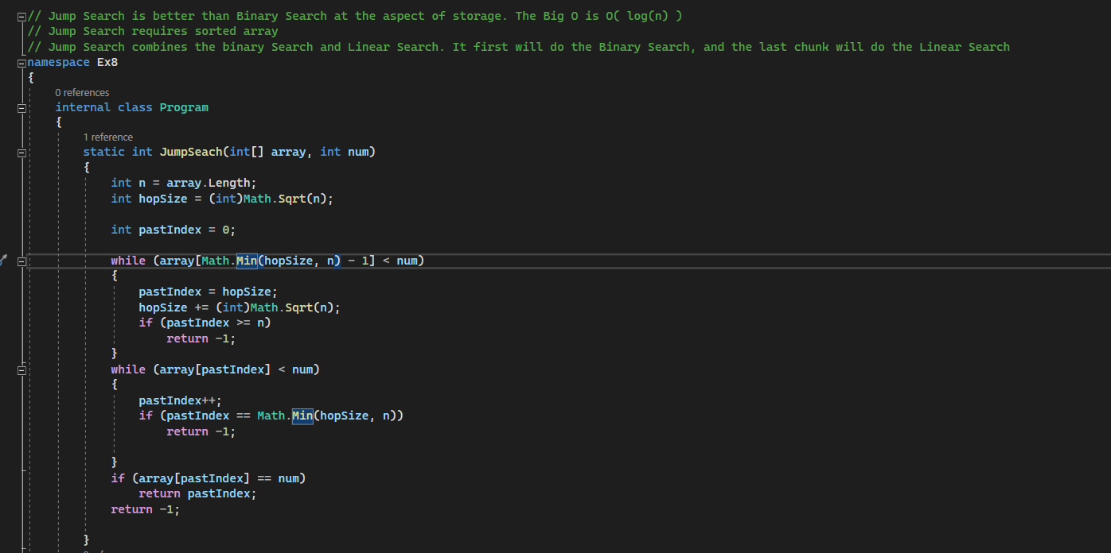

1. Stack:

* A stack is a linear data structure that the element which gets in first will be the last element fetch out (LIFO: Last I)
* Recursion is a method call itself
* Binary Search: has two ways to implement which are loop based and recursion-based
* Recursion requires a stack
* Exercise of Recursion:
  + Factorial Number:

* + Fibonacci Serial number:

Big O(n) of Fibonacci

1. Search Algorithm:

* Linear search: O(n): Search
* Binary search: O(log n) (log base is 2)

* Jump search: O(log n) (log base is 2) it will divide into multiple chunk then compare like the way of Binary search, the last chunk will use the the Linear Search. Jump Searrch requires sorted array. Jump Search is better than Binary Search at the aspect of storage
  + Nguyên lý cơ bản và ví dụ

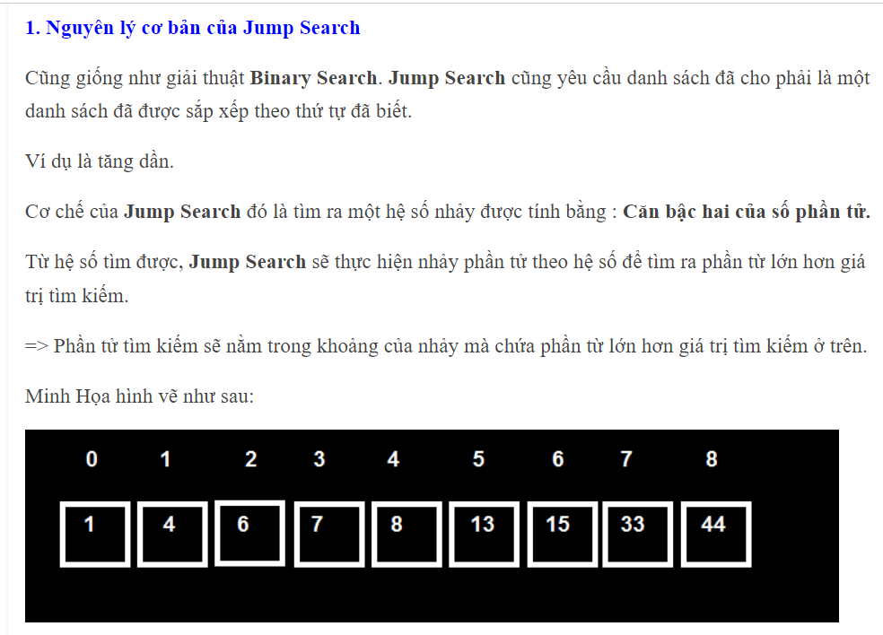

1. Sort Algorithm:

* Insertion sort: O(n^2): Insertion sort will compare index 0 and index 1 first then if value of index 0 > value of index 1, it will swap both of them. Then compare the value of index 1 with value of index 2, if value of index 1 > value of index 2, it will swap both of them. Then check again if value of index 1 now (which is the value of index 2) is it higher than value of index 0 if yes, swap them too. Then keep continue
  + The code illustrates below

* + Nguyên lý cơ bản và ví dụ:

* Selection sort: O(n^2) sSelection sort will take the value of index 0 as a minimum value then it will compare with the rest element of array which starts from index 1 (I will call the rest element of array is Rest_array), and the minimum value of the index in the Rest_Array which is smaller than the value of index 0 will swap with the value of index 0. Then it will start with the index 1 as a minimum value, and compare it with the rest element of array which starts from index 2, and the minimum value of the index in the Rest_Array which is smaller than the value of index 1 will swap with the value of index 1. Then keep continue.
  + The code illustrates below

* Quick sort: Big O(n * log(n) base 2)

* Merge Sort: Big O(n*log n base 2)

* Tim Sort: Big O(n*log n base 2) Combine Merge and Insertion, but there is no swap between the element just which one is minimum will attach the left side and which one is maximum will attach the right side. TimSort is

* Bubble Sort: Big O(n^2) Every Step takes two items index 0 and index 1. If they are in order, don’t do anything otherwise swap. They will take the next two items which are index 1 and index2, and do the same. However, it won’t compare value index 0 and value index 1 (is knows as value of index 2 before if the value of index 1 swap with value of index 2)

1. The best case to worst case

* O(1) < O(logn)< O(n) < O(n*logn) < O(n^2) < O(n^3)

1. Question:

* Members of List in C# need the same data type